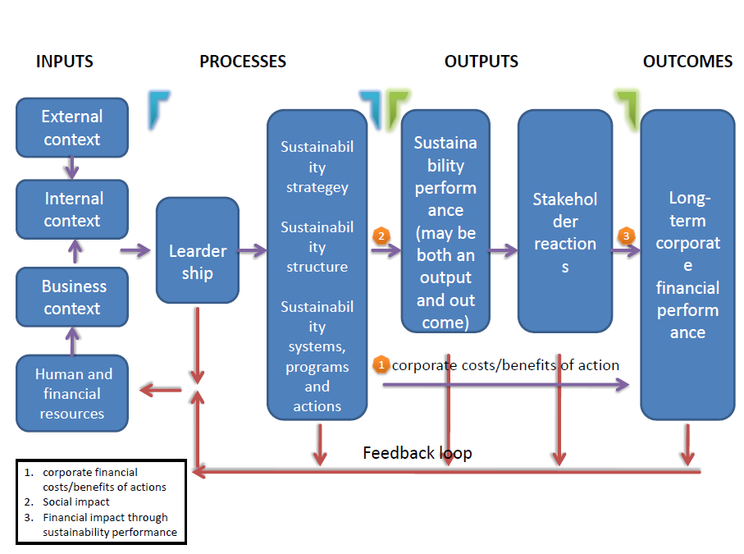

Methodology

This is the framework which I am going to use for the quick scan. This models integrates most aspects which are interesting for us: Stakeholder’s perspectives, quantitive & qualitive indicators and strategic & operational levels. The “input” is more related to the external conditions, where the company has not been involved yet. Accordingly, it is not interesting for the performance assessment of the company, so I decide to analyze and evaluate from the “process” stage, or operational level. The evaluation of the process will mainly based on the desk research of the company ( annual report, Sustainability report, the TNT website, etc..). In order to have an insight of the current situation of sustainability within the company, I will use descriptive method to evaluate four different aspects: leadership, strategy, structure and systems. A combination of desk research and questioners will be the method used to evaluate the outputs & outcomes. For instance, the financial performance will be assessed according to the data supplied by the annual reports or other sources. The employees’ reactions(part of the stakeholders ‘reactions) will be summarized by results of questionnaires. At the end, all evaluation will be presented in a score card as the conclusion for the quick scan of the company.

Processes (Internal analysis)

Leadership
It is important for leaders to consider all of these inputs if they want to formulate effective sustainability strategies. If the leaders are not knowledgeable enough about sustainability to motivate their subordinates or institute the proper strategy, structure, or systems, then sustainability actions are unlikely to be successful.(comments of the Chief Executive Officer/CEO) in annual report can be analyzed)
Sustainability Strategy, structure and systems
There are lots of examples which we can assess for those three different factors:
Strategy
1. Develop a mission statement (sustainability- related mission statement from annual report)
2. Consider global and local regulations, as well as voluntary standard (ISO 4000, ISO4001, SA8000, ISO14031, Dutch law specified in environmental factors)
3. Consider the impact of social investors (Individuals, investment funds, nonprofit organizations, and others who want to invest in companies that achieve positive social, environmental, and financial impacts)
Structure
- Integrated throughout organization; Manager access to top leadership; Effective use of human resources (Organizational structure)
- Aligned with strategy (analyzed by Porter’s value chain, scores)
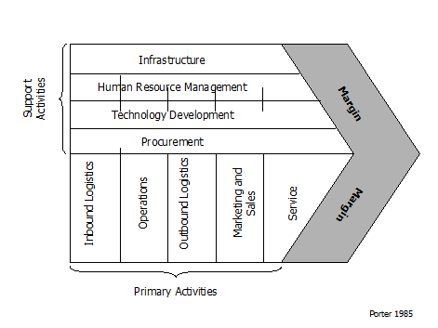
The porter’s value chain can be a good tool to help analyze the organization part.
Systems
- Costing and capital investment systems (Activity-based costing, life-cycle costing, full cost accounting, etc..)
- Risk management systems
- Performance evaluation and reward systems
- Measurement systems
- Feedback systems
- Reporting and verification systems

Descriptive-method Analysis
Aspects | Check lists | Overall Scores
Leadership | -Does the CEO focus on the sustainable issues?
 | -The priority of sustainability for leaders?
Strategy | -Do they have clear mission statement for sustainability field?
 | -Do they have those ISO certificates?
 | -Do they have any social cooperation plan? ( developing partnership with other non-profit organization)
Structure | -Do they have sustainability department?
 | -Is it effective to adapt the strategy into each department within current structures (By using porter’s value chain as a tool)?
System | -What kind of costing, risk management, sustainable performance evaluation systems are they using?
 | - Are those systems effective and efficient for their sustainable strategy?
 | - Are there any pros/cons?

Outputs/ Outcomes
Sustainability Performance
As recommended by Mr. Jan. Jansen, I decide to use the weighted score card to present the measurement result. There will be four dimensions : Stakeholder Reaction, Economic, and Environmental, and several indicators or metrics will be selected under each dimensions. Moreover, we will assess the long-term financial performance in this research in order to get a relative objective result.
Dell, the global computer company, has grouped its stakeholders into four categories which can be helpful for our research:
- Authorizers (Government, Shareholders, Board of directors)
- Business partners (Employees, Suppliers, Subcontractors)
- Customer groups (Consumers, Business, Government/Pubic)
- External influences (Media, Community members, Issues Advocates)

From Appendix 2, there are sample metrics for success-sustainability performance, but only a few important indicators will be used in the weighted score card:
Dimensions | Perspectives | Weight | Score (0-4) | Weighted Score
PROCESS (3/5 of Weights) | Leadership | 5
 | Strategy | 5
 | Structure | 2.5
 | System | 2.5
OUTCOMES/OUTPUTS (2/5 of Weights) | - ROI ( Return on investment) | 2
Economic Factors | - Cost Saving from reduction in fuel costs | 2
 | - Cost of capital investments for sustainability projects | 0.62
Environmental Factors | - Volume and cost of energy/fuel use | 0.62
 | - Volume of emissions to air (CO2, NO2, etc.) | 2
 | - Percentage of electric vehicle used | 0.62
 | - Number of Sustainable lawsuits | 0.3
Stakeholders' Reactions | - Changes of Share prices | 0.3
 | - Employee satisfaction scores | 0.62
 | - Suppliers’satisfaction scores | 0.3
 | - Number of people benefits from their social responsibility projects | 0.62
 | In total | 25

Appendix
Appendix 1. Stakeholder‘s Perspectives of TNT
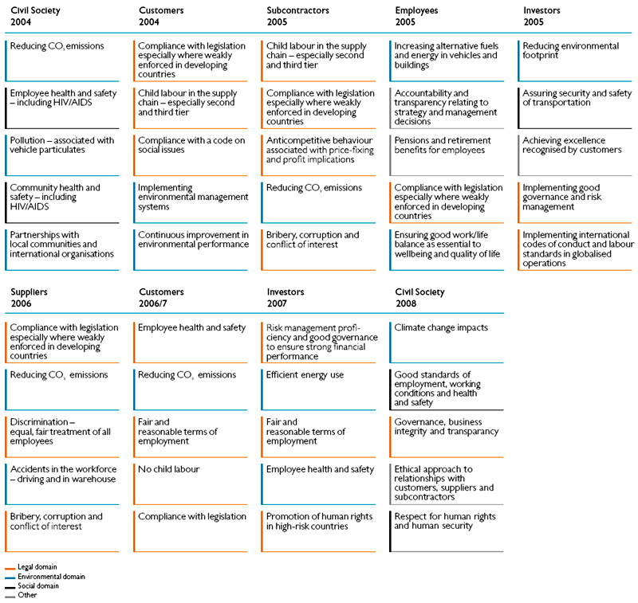

Appendix 2. Sustainability Performance Indicators
Sustainability Performance Indicators
Economic factors:
Quantitive indicators:
- ROI ( Return on investment)
- Cost Saving from reduction in fuel costs
- Cost of capital investments for sustainability projects
Environmental indicators:
Quantitive indicators:
- Volume and cost of energy/fuel use
- Volume of emissions to air (CO2, NO2, etc.)
- Noise levels in community
- Percentage of electric vehicle used
Qualitive indicators:
- Type of fuel used (97#, 93#, etc.)
- Type of Vehicles used
- Number of Sustainable lawsuits
Stakeholders’ reactions
Authorizers (Government, Shareholders, Board of directors)
Quantitive
- Changes of Shareprices (maybe especially after the implements of the sustainability projects)
- Funds invested??
Qualitive
- Government awards
- Board of directors’satisfications (maybe not possible)
Business partners (Employees, Suppliers, Subcontractors)
Quanlitive
- Employee satisfaction scores (Sustainability related salary bonus, Number of lost work days, Percentage of increased wages)
- Suppliers’satisfaction scores (Funds invested by other partners( suppliers or subcontractors))
Customer groups (Consumers, Business, Government/Pubic)
Quantitive
- Percentage of increased Market shares
External influences (Media, Community members, Issues Advocates)
Quantitive
- number of positive news reported by media
- Do they spoons or support any social activities to return benefits to society?
- Do they have any partnership with other environmental organizations?
- Are there any awards related to social responsibilities?
Qualitives
- Investments on social responsibility activities
- Number of people benefits from their social responsibility projects

There is an overlap between social aspects and stakeholder’s reaction, so we will use stakeholder’s reaction instead of Social aspects.

